Ping Local Native User App Prompt

Ping Local is an app where businesses can upload VERY limited promotions to an app for consumers based in Wirral, Merseyside. Users can either buy upfront promotions that they redeem with a QR code, or book in a promotion that they pay for on arrival, using a QR code to verify a discount.

There are three sides to the app, a user (consumer) side, a business side and an admin side. As we’re transitioning away from Adalo, we’ve decided to build the user side in react native.

User Side

Users can browse a customised ‘feed’ of promotions which is tailored to them, they can view this as a list or as a map with pins for each business. They can favourite promotions and businesses and have a page to view them.

The main draw of the app is that users can claim or buy a promotion in a limited time (explained further in the business section) - for example, “pay £20 and receive a free drink with your meal” could be a promotion somebody buys. In that scenario they’d pay the £20 in app, turn up and open a QR code for the restaurant to scan and verify that it’s a prepaid discount.

Promotions have certain tags and metadata attached to make them filterable, primarily tags which feature categories and features, as well as a general location area (different to their address, and is just an entry in the database for ‘birkenhead’, or ‘prenton’). When chosen by location, the feed should be sorted by proximity to the user, or if they do not have location enabled, then by proximity to the center of the selected town/village.

Promotion Detail and purchasing/claiming promotions

When clicking into a promotion, the user should be able to see all of the relevant information, such as how much stock is left, when the promotion ends, if there are any special notes or policies written by the business etc. At the top there is a buy now button that can feature different text depending on if the user needs to book or not.

There is a total of 5 different routes a customer can take to claim a promotion based on the promotion type and booking type - these all start from clicking the ‘buy now’ button on the promotion detail page;

- Pay up front / No Booking: The user is taken directly to a payment checkout with Stripe integration and a quantity selector if allowed. Once paid they receive loyalty points (cost*10) and are redirected to the claimed pings page.
- Pay up front / Slot or Restaurant Booking: The user is taken to a calendar where they can select a predetermined slot created by the business, before being taken to the payment screen with Stripe integration and a quantity selector if allowed. Once paid they receive loyalty points (cost*10) and are redirected to the claimed pings page.
- Pay up front / Book by call or URL: The user is notified that they’ll need to book outside of the app, and asked how many they think will be in their party - but is otherwise taken through to the checkout with Stripe integration and a quantity selector if allowed. Once paid they receive loyalty points (cost*10) and are redirected to the claimed pings page.
- Pay on the day / No Booking: The user is asked to confirm that they accept the promotion before being taken through to a different checkout page, this time showing the details of the promotion and a simple ‘claim’ button, which doesn’t offer loyalty points but redirects the user to their ‘claimed pings’ page.
- Pay on the day / Slot or Restaurant Booking: The user is taken to a calendar where they can select a predetermined slot created by the business, once choosing being taken to a different checkout page, this time showing the details of the promotion and a simple ‘claim’ button, which doesn’t offer loyalty points but redirects the user to their ‘claimed pings’ page.
- Pay on the day / Book by call or URL: The user is notified that they’ll need to book outside of the app, and asked how many they think will be in their party - then are taken to a different checkout page, this time showing the details of the promotion and a simple ‘claim’ button, which doesn’t offer loyalty points but redirects the user to their ‘claimed pings’ page.

Redeeming Promotions and QR Codes

The user then has their ‘claimed pings’ page, where they can see any purchased/claimed promotions that they can use. This is where they can generate a QR code for a promotion to be redeemed via the company scanning it with a QR scanner.

If the promotion is a ‘pay up front’ promotion type, the process is:

- The user asks to use their Ping Local app to verify that they have a discount or can pick up an item, opens up QR Code.
- The business then opens their ping local app and clicks on the QR scanner option.
- When the business scans the users QR code, the business is shown the promotion to confirm it’s the correct one.
- Once confirmed the users app will be notified that the promotion has been successfully redeemed.

If the promotion is a ‘pay on the day’ promotion type, the process is:

- The user asks to use their Ping Local app, opens up a QR Code.
- The business then opens their ping local app and clicks on the QR scanner option.
- When the business scans the users QR code, the business is shown the promotion to confirm it’s the correct one.
- If they sign off that it’s correct they’re then asked to input the bill, which will then be presented on the users screen, letting them confirm it (it’s up to the user to verbally raise if the amount is wrong, there’s no dispute button).
- When the user is happy they can click continue, where they receive their loyalty points, which will be the bill*10.

Business Directory

There is a business directory as well where they can view the different businesses that use the app. When viewing a business, the user can see their latest promotions, where they are on a map, what ‘features’ they have and basic details like description, title etc.

Loyalty Points

Users also have loyalty points, that they earn either by paying in app, or by redeeming promotions on the day if they don’t have to pay up front. There are 4 levels to this, Local Member, Local Hero, Local Champion and Local Legend.

The tiers are broken into the following;
- Local Member: 0 - 10 points
- Local Hero: 10 - 1200 points
- Local Champion: 1200 - 10,000 points
- Local Legend: 10,000 - infinite points

The user has an icon in the header of the app that reminds them of their tier. There is also information on the ‘my account’ screen that shows the user in a progress bar how far into their ‘tier’ they are, as well as info on the tiers themselves.

Adalo Structure and pages

- Login Flow
  - Onboarding Screen 1
  - Onboarding Screen 2
  - Onboarding Screen 3
  - Onboarding Screen 4
  - Verification Screen (user receives email and must input generated code to access rest of the app)
  - Verification Success Screen (once correct code inputted)
- Home Feed - no useroffers (only shows while the algorithm is generated)
- Home Feed (shows once items in useroffers with the user ID contain more than one item)
- Offer Detail Screen
  - Accept Promotion Screen - Choose slot (if promotion is time-slot based)
  - Accept Promotion Screen - Phone / URL (if promotion needs to be booked by phone or external URL)
  - Payment Screen (non slot based)
  - Payment Screen (for any other type of promotion)
- Business Directory
  - Business Detail Page
- Favourites
  - Favourite Business
  - Favourite Promotions
- Account
  - Loyalty Points Information
- Notifications
  - Notifications Detail
- Settings
  - Change user details
    - Change Password
  - Delete Account
  - FAQ Section
- My Claimed Promotions
  - QR Code Generator
    - Loyalty Point Success Screen (when QR scanned and confirmed)
    - Bill Query page (if it’s a ‘pay on the day promotion’)
    - Promotion Claimed Page

Screens and Behaviour
The below is a bullet-pointed list of screens in the app, as designed in adalo, I give an explanation of what each screen does, and what’s featured where adalo’s ‘magic text’ or dynamic visibility is involved. Screenshots immediately below bullet points are relevant to that above bullet point and only to that one, although there is written information that may be shared between screens.

- Welcome Screen: Standard login / register screen - can supply images for background and graphic woman.
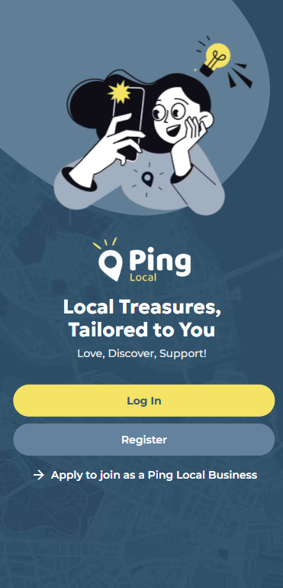
- Sign Up Screen: Can supply graphic, back button takes you back to welcome screen.
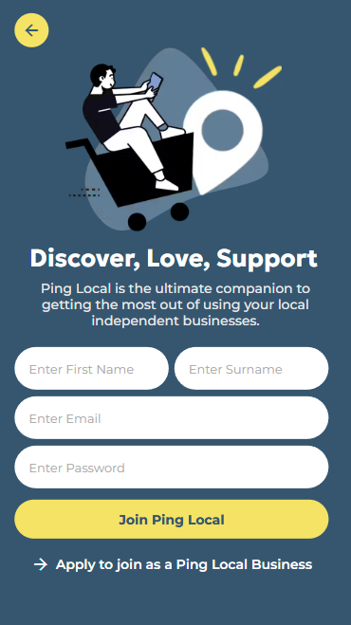
- Login Screen: Standard behaviour
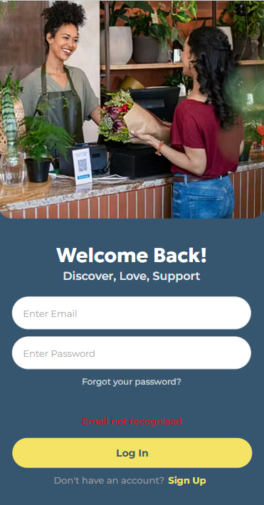
- Onboarding Screens 1-4 (in order) accessed when Signing up for the first time. Onboarding screen 4 (the one that says ‘don’t miss out’) should prompt the user to allow notifications in the app.
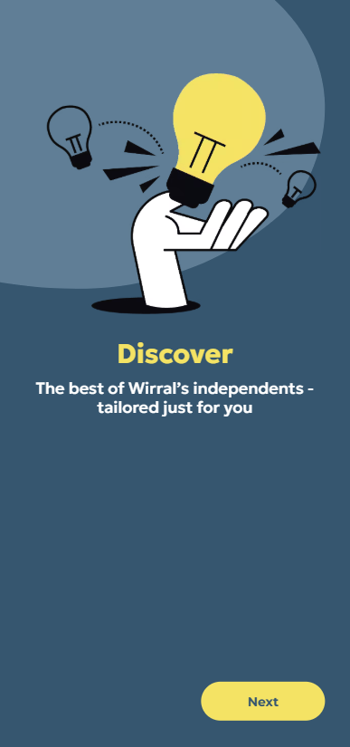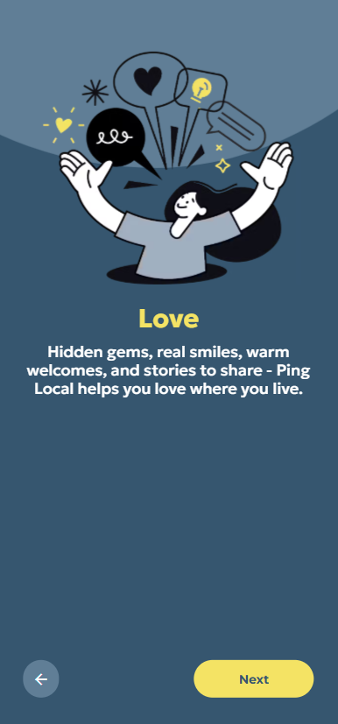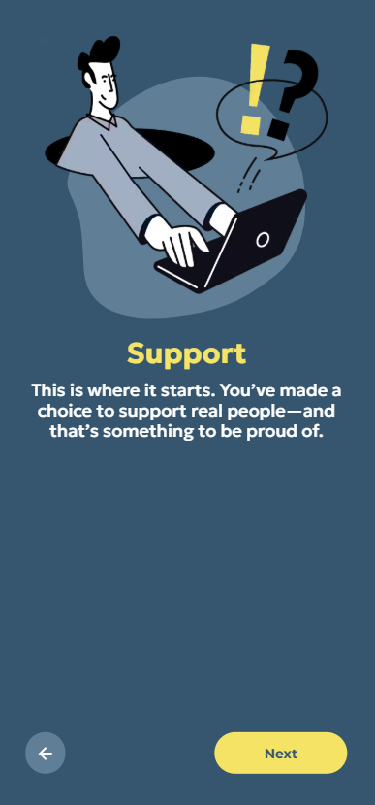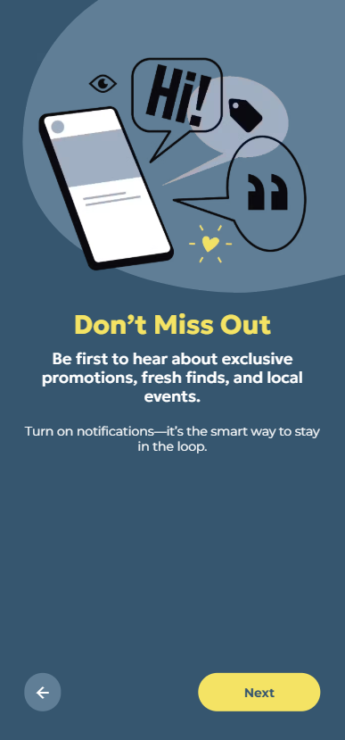
- Verification Screen and Success: The user has to type in their verification code in order to access the app. Correctly typing in the code should mark the user as ‘verified’ in the database. If they need to resend an email the ‘don’t have a code? Send a new one’ text should generate a new code and email the user. The second screenshot is a pop up modal.
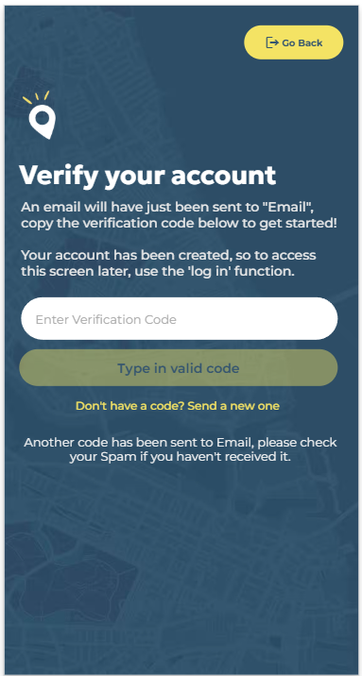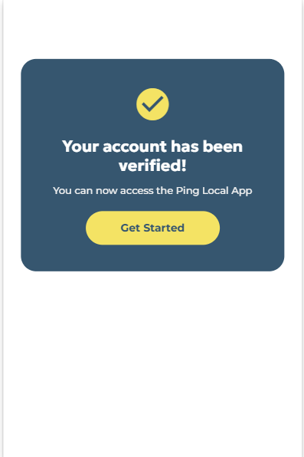
- Home Page: The central feed of promotions features the title of the promotion, the company, location and end date, as well as proximity to the user and the status of the promotion, the grey section is where the feature image of the promotion goes. In the header, The notification bell icon has an indicator in that tells you how many unread notifications you have. The top left circle shows an icon for the users current loyalty tier.
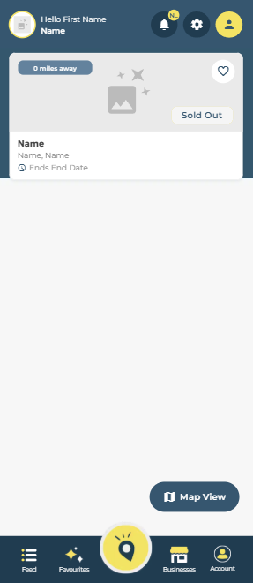
- Promotion Detail Page: There’s quite a lot of content here that only shows depending on the content. Going top to bottom we have the main image section, which if the item is a quantity item will show the remaining quantity. Below we have the title, company and location of the promotion. On the right we have the Buy Now block, which features the CTA to purchase or claim the promotion, a price if available, the unit (item, person, box etc.) of the promotion and the end date. Underneath is a list of features the product can have. If the promotion has ended then there’s a red box, that says ‘this promotion ended at [end time of promotion]’. Underneath this is the description for the promotion. Underneath this is a special note written by the business if there is one available. Under this we have a link to the terms and conditions of the promotion. Then underneath this we have the image gallery of extra photos if the business has uploaded any. Then finally we have a block with the business name, joined date, a link to view them on a map and their featured image.
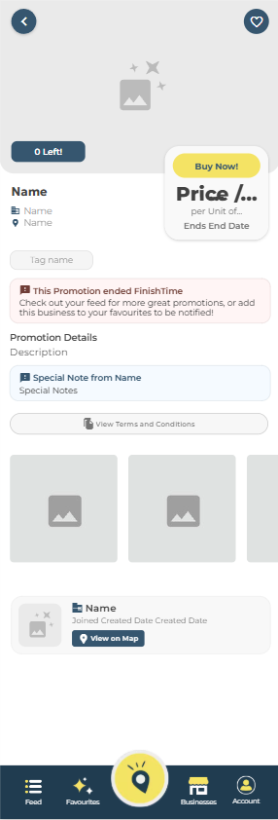
- Claim / Purchase Promotion (slot based) - if it’s a slot based promotion, then the user has a two step flow to choose their slot (for example time for a meal at a restaurant). They pick the date on the calendar and then see the available times to pick from.
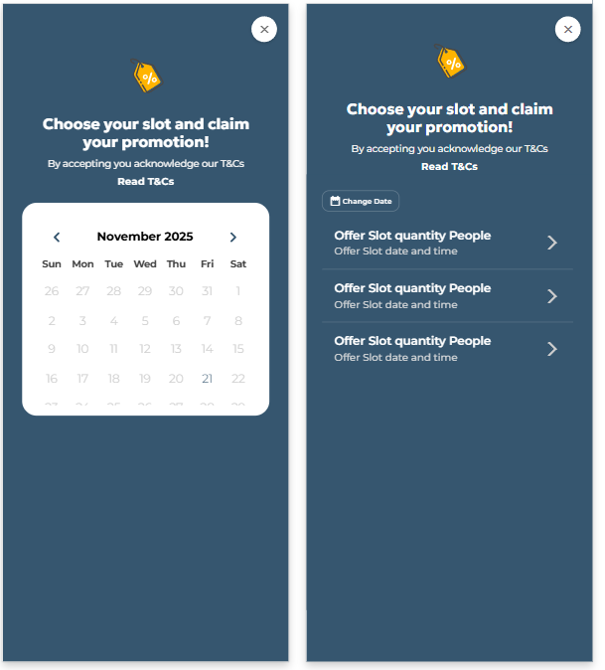
- Claim / Purchase a promotion (phone / URL based): The user is simply taken to a screen where they are advised that they’ll need to book outside the app, but to write how many people they’re intending to bring along to the booking.
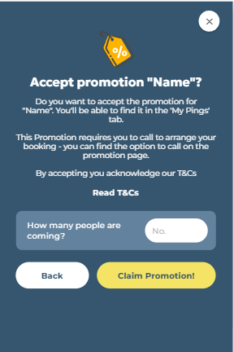
- Payment Screens: The left payment screen is for non-slot based promotions, but the right is for slot based. The main difference is that the offer slot information (time and the amount of people) is shown near the top. On both there’s a stripe payment gateway if it’s a ‘pay up front’ promotion, but will be hidden if it’s a ‘pay on the day’ promotion, and vice versa with the ‘confirm booking’ button at the bottom.
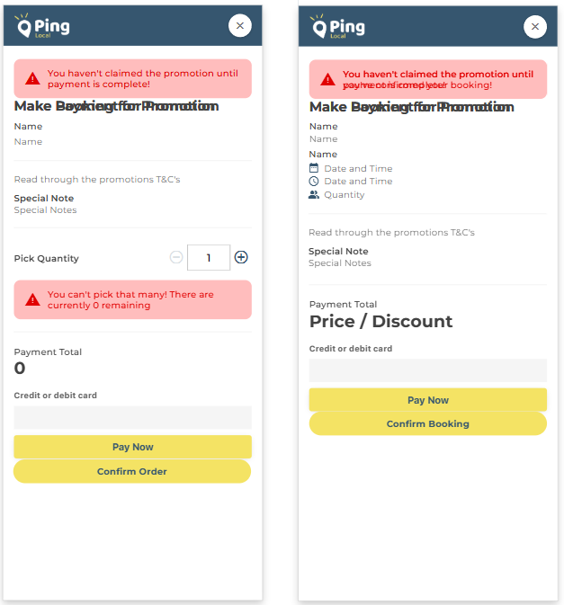
- Payment Success Screen: If it’s a pay up front promotion, the user will see the left screen, see what loyalty points they’ve received and be told if they’ve levelled up. If it’s a pay on the day promotion, then they see the screen on the right.
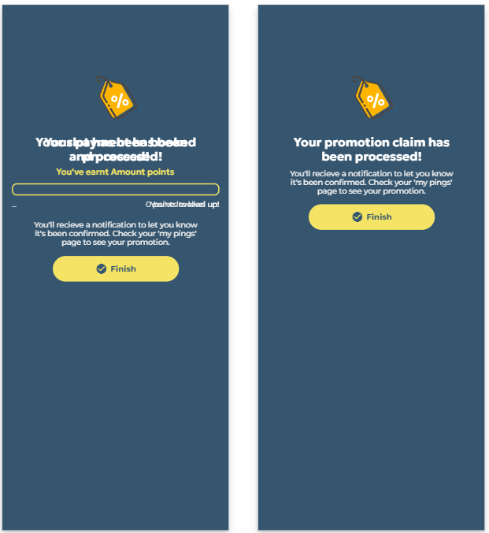
- Confirm Bill Screen: If the user has had their QR Code scanned and the promotion is a ‘pay on the day’ promotion, the business will need to input the customers bill manually on their device. When they submit that amount the customer should be shown this screen to confirm that it is correct, once they have they should then be congratulated and returned to the claimed promotions page.
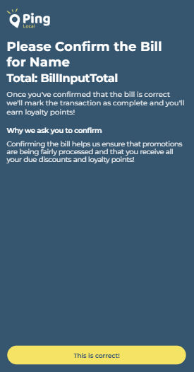
- Business Directory: This is a list of businesses that list promotions on the app. The top cards are a scrollable carousel list of businesses ticked as ‘featured’ in the database. Underneath is a generic list of all businesses, with the name, location, features and how many live promotions they have.
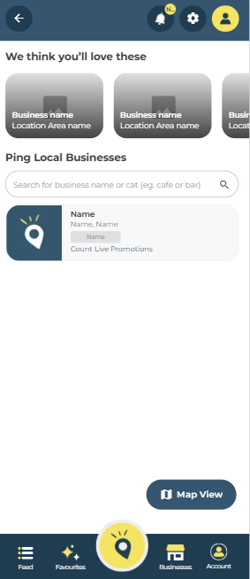
- Business Detail Page: The top section is the featured image for the business, and the business name and location are overlaid on top. Underneath are the business ‘tags’. Underneath is the business description. After that there are the recent promotions. Underneath that is a map with where the business is located.
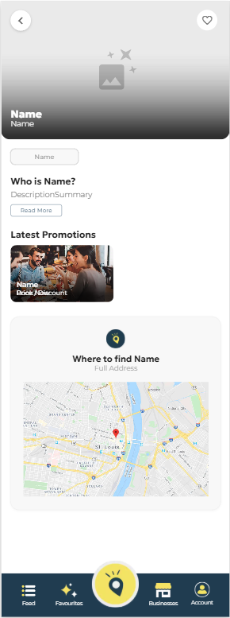
- FAQ Section: This is a list of database entries that contain useful information on how to use the app. The left is the main list and the right is a detail page when you click into a specific FAQ.
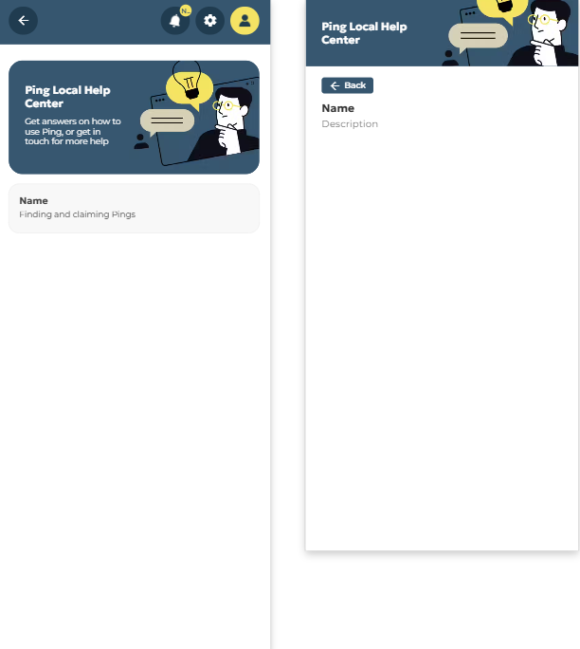
- Claimed Pings Page: This is where a user can view their claimed promotions and redeem them. Each card contains information from the promotion, including the featured image, the title, business and location, when it’s booked for or when it expires, the price they paid and an option to redeem it. When clicking on ‘redeem now’ it brings up the QR Code. There is a graphic and some text that will display if the user hasn’t yet purchased anything.
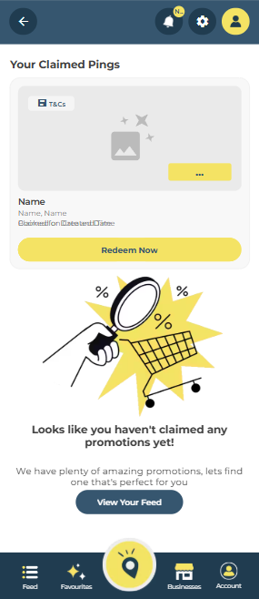
- QR Code Modal: This shows up when the user clicks on ‘redeem now’, with the QR code for the business to scan, this should then pass through the correct promotion for the business to sign off on.
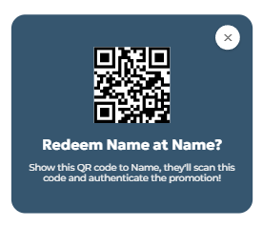
- Favourite business / promotion page: This is where a user can find any business or promotion they have added to their favourite list. They can switch between tabs to show a list of either one.
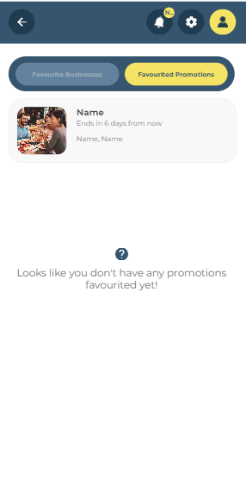
- My Account: This shows the users currently loyalty tier at the top, the circle in the middle being their loyalty tier icon. The progress bar below shows how close they are to leveling up another tier. Underneath is a card about the loyalty scheme they can click for more information. Below that is their redemption history (purchased AND redeemed promotions).
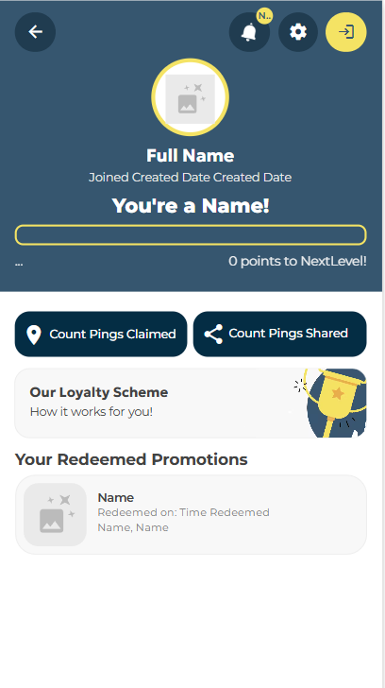
- Loyalty Scheme information: This just displays the 3 loyalty tiers (it excludes local member as it’s the default) and gives some info in each
